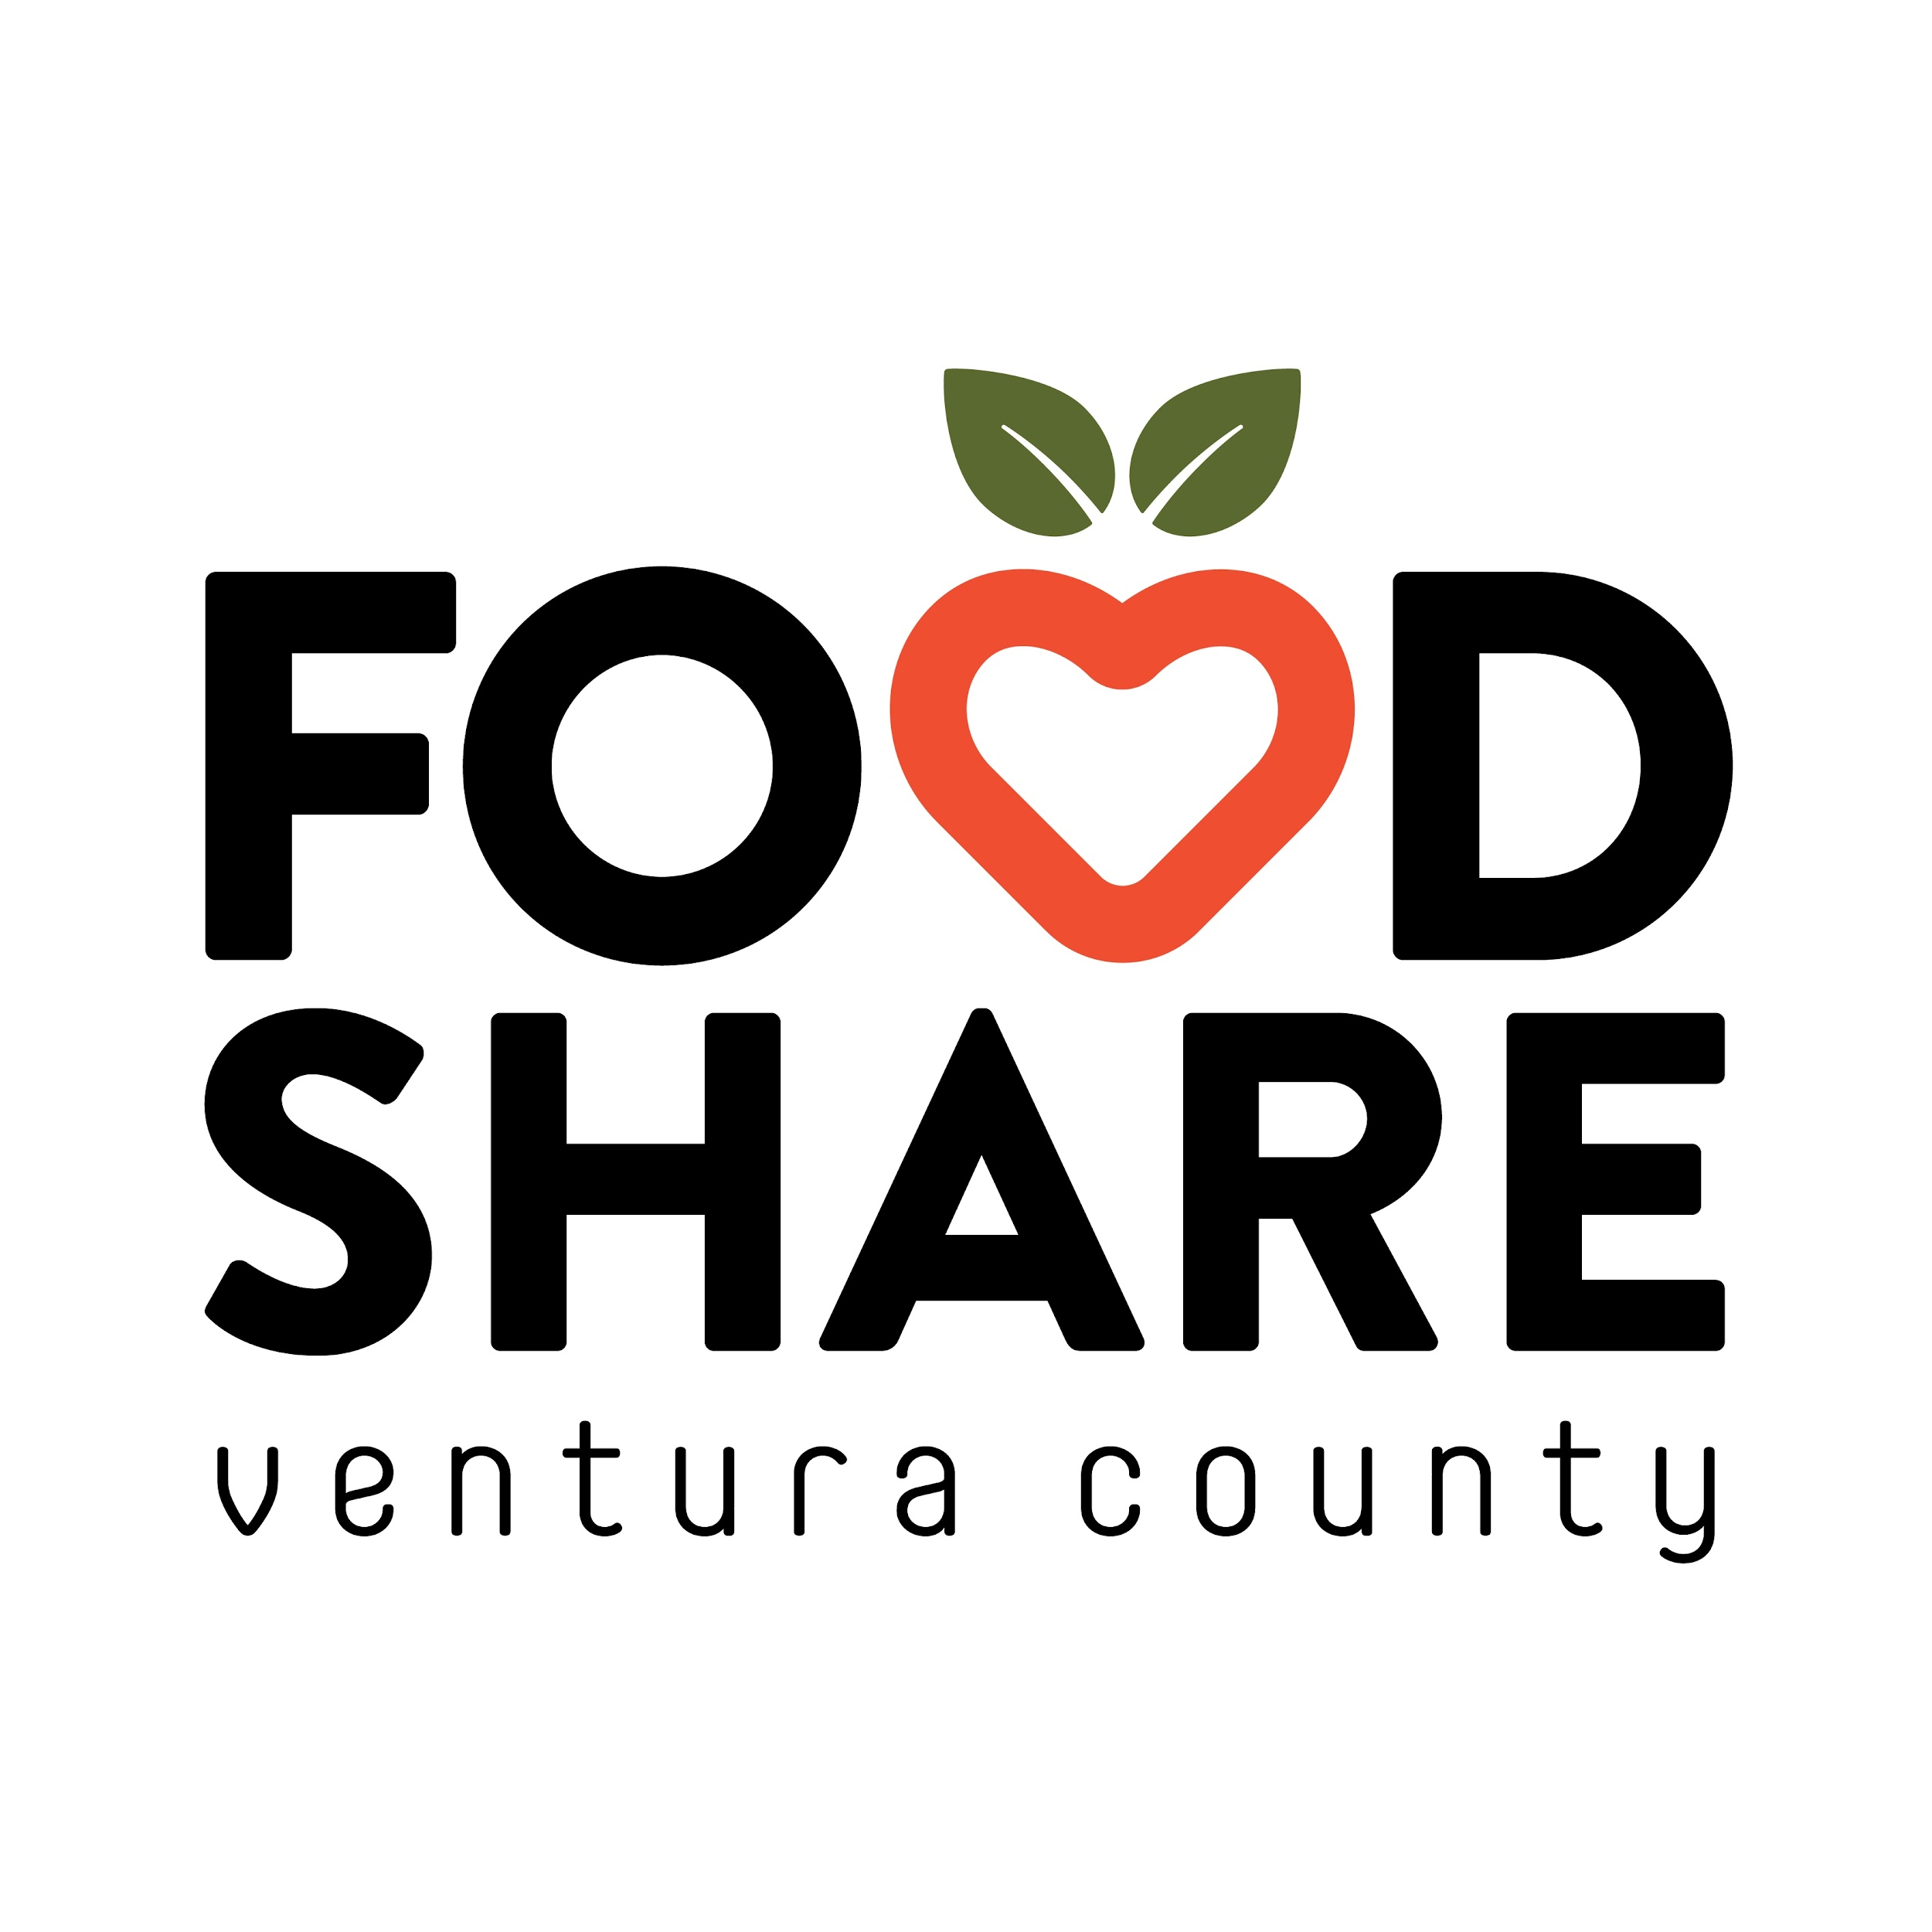

**FOR IMMEDIATE RELEASE**

November 07, 2024

**Food Share Supports Three Emergency Food Distribution Events for Ventura County Residents Affected by Fire and PSPS Events**

Ventura, CA – In response to the recent fires and ongoing Public Safety Power Shutoff (PSPS) events affecting Ventura County, Food Share is supporting four emergency food distributions to help our community. These events will provide essential food supplies to families and individuals facing immediate hardship due to evacuations, power outages, and displacement.

Monica White, President and CEO of Food Share of Ventura County, highlighted the organization’s commitment to crisis response: “Hunger is an ongoing disaster that we address daily. We are equally prepared to support our neighbors through these emergency events, ensuring they can access essential food resources when needed most.”

**Emergency Food Distribution Events**

**Thursday, November 7, 2024**

* **Date:** 11/07/2024
* **Time:** 4pm - 6pm
* **Location:** Crossroads Community Church, 161 Plaza La Vista, Camarillo, CA 93010.
* **Type:** Drive-thru distribution until supplies last.

**Friday, November 8, 2024**

* **Date:** 11/08/2024
* **Time:** 11am - 1pm
* **Location:** Pleasant Valley Recreation and Park District at theCamarillo Community Center, 1605 Burnley Street, Camarillo, CA 93010.
* **Type:** Drive-thru distribution until supplies last.

**Saturday, November 9, 2024.**

* **Date:** 11/09/2024
* **Time:** 12:30pm - 2:30pm
* **Location:** Ruben Castro Charities, Moorpark College, 7075 Campus Road, Moorpark, CA 93021.
* **Type:** Drive-thru distribution until supplies last.

**Wednesday, November 13th, 2024**

* **Date:** 11/09/2024
* **Time:** 2pm - 4pm
* **Location:** College Park, 3250 S. Rose Ave, Oxnard, CA 93033.
* **Type:** Drive-thru distribution until supplies last. Please show ID.

These distributions are open to all Ventura County residents impacted by the fires and PSPS events and all who are facing any type of food insecurity. Families and individuals can expect to receive essential food items, including ready-to-eat food, fresh produce, non-perishable items, and pantry staples. No proof of income or eligibility is required.

### **Stay Informed**

For additional information and regular updates on these emergency distributions, visit [foodshare.com/findhelp](https://www.foodshare.com/findhelp). Ventura County residents affected by PSPS events can also find resources and information by visiting Southern California Edison’s PSPS page at[www.sce.com/psps](http://www.sce.com/psps) and Ventura County’s [www.vcemergency.com](http://www.vcemergency.com) for regular updates.

###

**Background information:**

Food Share’s mission is to lead the fight against hunger in Ventura County. As Ventura County’s regional food bank, Food Share provides annual food for 267,000+ hungry friends and neighbors. Staff and volunteers distribute over 19 million pounds of food, providing 16 million meals annually to Ventura County residents through its hunger programs and 160 pantry and program partners. Food Share is a member of Feeding America, the nation’s largest hunger-relief network of food banks, and the California Association of Food Banks**.**

**Media Inquiries:**

Jennifer Caldwell,

Chief Development Officer,

Cell:(805) 479-1147

[Jcaldwell@foodshare.com](mailto:Jcaldwell@foodshare.com)