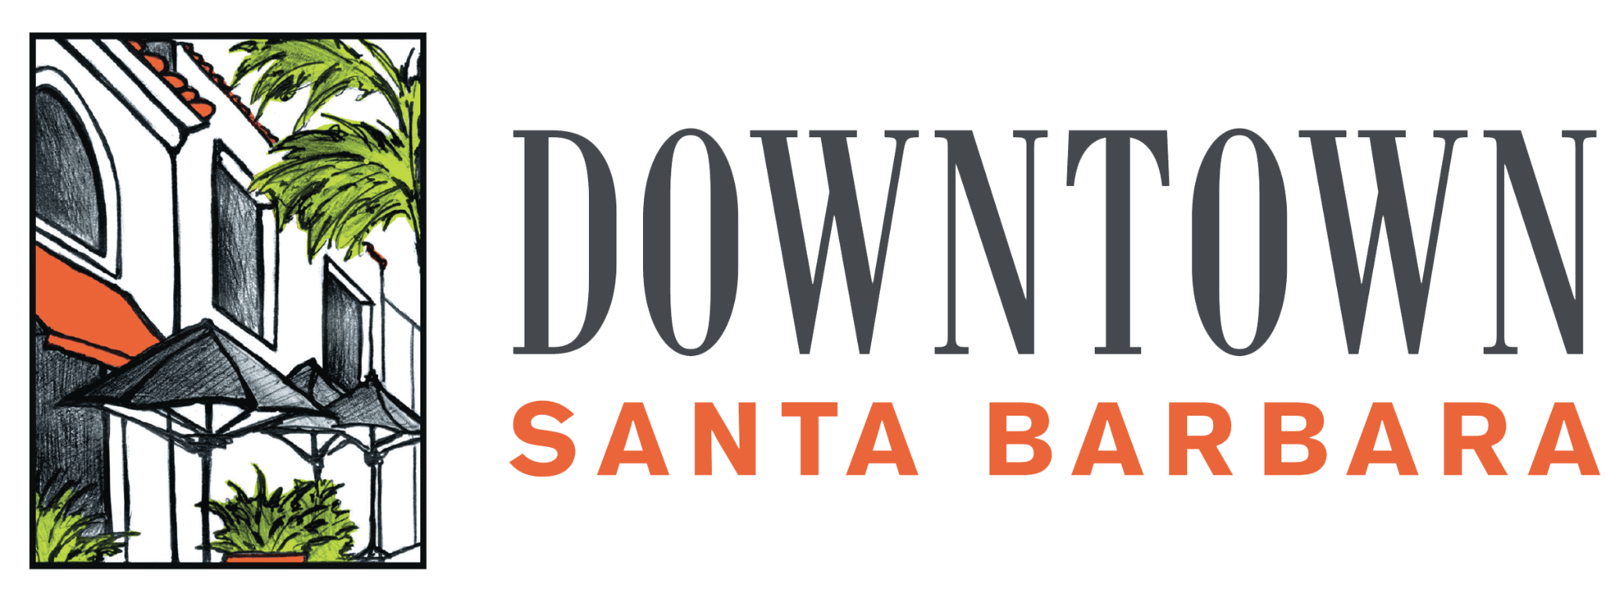

**PRESS RELEASE**    
November 20, 2024  
For Immediate Release

**Contact:**Christy Jacobs

Events & Communications Coordinator  
[Christy@downtownsb.org](mailto:Christy@downtownsb.org)  
805-962-2098  
Downtown Organization of Santa Barbara Inc.

**Downtown Santa Barbara Holiday Happenings:**

**Prince & Fairy Art Contest, Christmas Tree Lighting, Small Business Saturday, Holiday Spirits Party, and More!**

SANTA BARBARA, CA - The holiday season in Downtown Santa Barbara brings with it a festive blend of tradition and community spirit, highlighted by the lighting of the spectacular community Christmas tree—an honor bestowed upon two talented local children.

As part of this cherished tradition, young artists in grades K-6 are invited to participate in the annual Prince & Fairy Art Contest. This year’s theme is “Holiday Hopes and Dreams.” Artists are encouraged to create a drawing on paper no larger than 11” x 17.” After a thorough judging process, the two winning artists will receive the exciting news: they have been chosen to light the downtown Christmas tree!

To enter the contest, aspiring artists should download the application [**here**](https://www.downtownsb.org/_files/docs/2024princeandfairycontest.pdf) and submit it via email to Christy@downtownbs.org or drop off/mail to Downtown Santa Barbara (27-B East de la Guerra Street).

Key Dates:

* Application Deadline: Friday, November 22, by 5:00 PM
* Winners Announced: Wednesday, November 27
* [**Christmas Tree Lighting Ceremony**](https://www.eventbrite.com/e/annual-downtown-holiday-tree-lighting-event-tickets-1082642114709?aff=oddtdtcreator)**: Friday, December 6, from 5:00-7:00 PM.**

*Please ensure that participants can attend the Christmas Tree Lighting event when entering the contest.*

[**Sutter Health**](https://www.sutterhealth.org/)has joined in on the festivities this year as a Silver Sponsor, along with long time sponsor[**Consumer Fire Products, Inc.**](http://www.consumerfireproducts.com/) (CFPI). *"Sansum Clinic, now part of Sutter Health, is proud to partner with Downtown Santa Barbara to continue this beloved holiday tradition, reinforcing our commitment to the health and well-being of our community. We’re honored to support events that bring joy and connection to the people we serve!"* said Kurt N. Ransohoff, MD, FACP, President, Sutter Health, Greater Central Coast.

Consumer Fire Products Inc. is once again assisting with procuring the Community Christmas Tree to be installed in the middle of State Street. *“At CFPI, we are thrilled to return as sponsor of this year’s State Street Christmas Tree! With over ten years of supporting Santa Barbara’s beloved downtown holiday celebrations, we understand how important this holiday tradition is to the community. We’re excited to partner with DSB and help light up the season with this joyous addition once again,* saidIrene Rhodes, owner and CEO of CFPI.

In addition to the tree lighting, be sure not to miss the **Downtown Holiday Spirits Party** on Tuesday, December 3, from 5:30-8:30 PM at the Lobero Theatre. This festive celebration will feature live music from The Coveralls, merry cocktails, and tasty bites, making it the perfect way to kick off the December holiday season downtown. Learn more and purchase tickets [**here**](https://www.eventbrite.com/e/downtown-holiday-spirits-party-tickets-1066104921519?aff=oddtdtcreator).

Other holiday events include [**Small Business Saturday**](https://www.eventbrite.com/e/downtown-small-business-saturday-tickets-1086964563269?aff=oddtdtcreator) on Saturday, November 30, [**Holiday Sing-Along with the Prime Time Band**](https://www.eventbrite.com/e/downtown-holiday-sing-along-with-the-prime-time-band-tickets-1082648012349?aff=oddtdtcreator) on the front steps of the Santa Barbara Museum of Art (1130 State Street) on Friday, December 13 from 6:00-8:00 PM, and the [**Big Brass Christmas Concert**](https://www.eventbrite.com/e/big-brass-christmas-concert-tickets-1082651141709?aff=oddtdtcreator)in Storke Placita (700 Block of State, between Blenders in the Grass and Supercuts) on Saturday, December 14 from 12:00-2:00 PM, as well as **Downtown Holiday Caroling** various evenings during the first two weeks of December.

To learn about more community downtown holiday events visit our [holiday happenings](https://www.downtownsb.org/events/holiday-happenings) page on the website.

If you or your company would like to assist in brightening the season as a sponsor, please reach out to Robin Elander, Executive Director at [Robin@downtownsb.org](mailto:Robin@downtownsb.org).

*The Downtown Organization of Santa Barbara, Inc. (DSB) is dedicated to the promotion*

*and enhancement of the Santa Barbara Downtown District for the benefit of its 1,700+ businesses, Santa Barbara residents and visitors. DSB has a long history of leading change, organizing community, and building the brand Downtown Santa Barbara. For more information about our programs, events, and a directory of downtown businesses visit* [*www.DowntownSB.org*](http://www.downtownsb.org)*.*

###